GE Healthcare
Save CT Protocols using Dose Check Software to view as Excel File
Operator Console • Quick Reference Guide

One possibility to save protocols as Excel File is to use the Dose Check Management Tool.

Dose Check Management Tool

- Select Protocol Management
- Select Dose Check Management

- In the Dose Check Management Tool select Audit Tool.
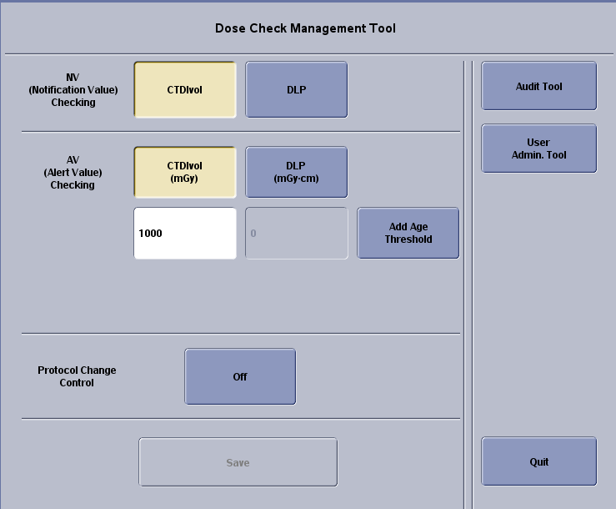

- The Dose Audit Tool appears on the rights screen.


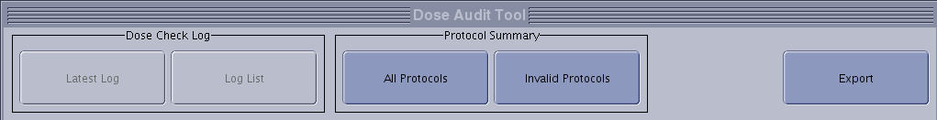
- Select Export.
- In the Select Export Option select the desired Export Media and Export Contents. Select ALL Protocols and click OK.
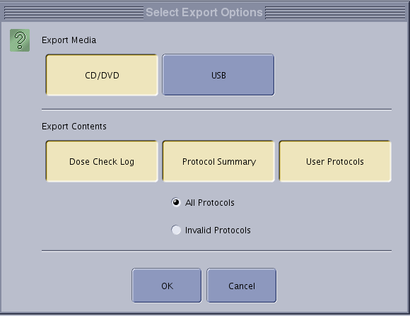

- You can use the Media on the PC now. Select the .csv file to view the protocols.

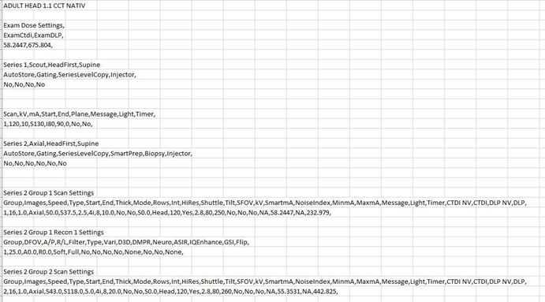

WARNING! The materials contained in this document are intended for educational purposes only.
This document does not establish specifications, operating procedures or maintenance methods for
any of the products referenced. Always refer to the official written materials (labeling) provided with
the product for specifications, operating procedures and maintenance requirements. If you need help,
please contact the Online Center.

GE and the Monogram are trademarks of General Electric Company.

